Attribute

🔹 What is Attribute
# Source: AI Source: Provided by: [Data Path: Persons Table -> ID Column: 1, Name_En Column: Motasem Essam] -> From: [Chatgpt (GPT-4-turbo)] on [8/3/2025]
In grammar, an attribute is a grammatical function that provides descriptive information about a noun within a noun phrase.
It is usually realized by adjectives, but it can also be an adjective phrase, participle, noun, numeral, or genitive.
🧠 The attribute modifies or qualifies the head noun of a noun phrase and typically appears before the noun in English.

✅ Key Characteristics of Attributes:
# Source: AI Source: Provided by: [Data Path: Persons Table -> ID Column: 1, Name_En Column: Motasem Essam] -> From: [Chatgpt (GPT-4-turbo)] on [8/3/2025]
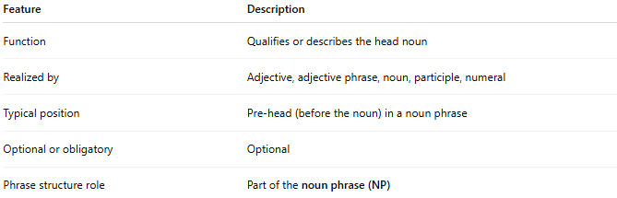
Feature | Description
Function | Qualifies or describes the head noun
Realized by | Adjective, adjective phrase, noun, participle, numeral
Typical position | Pre-head (before the noun) in a noun phrase
Optional or obligatory | Optional
Phrase structure role | Part of the noun phrase (NP)

✅ Examples of Attributes in Noun Phrases:
# Source: AI Source: Provided by: [Data Path: Persons Table -> ID Column: 1, Name_En Column: Motasem Essam] -> From: [Chatgpt (GPT-4-turbo)] on [8/3/2025]
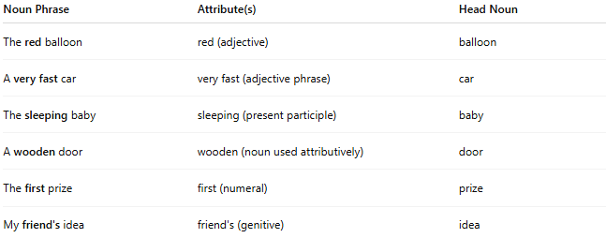
Noun Phrase | Attribute(s) | Head Noun
The red balloon | red (adjective) | balloon
A very fast car | very fast (adjective phrase) | car
The sleeping baby | sleeping (present participle) | baby
A wooden door | wooden (noun used attributively) | door
The first prize | first (numeral) | prize
My friend's idea | friend's (genitive) | idea

✅ Types of Attributes:
# Source: AI Source: Provided by: [Data Path: Persons Table -> ID Column: 1, Name_En Column: Motasem Essam] -> From: [Chatgpt (GPT-4-turbo)] on [8/3/2025]
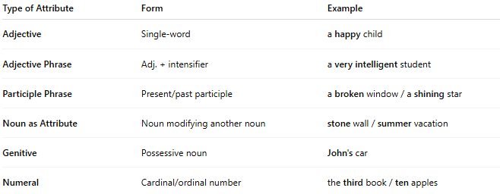
Type of Attribute | Form | Example
Adjective | Single-word | a happy child
Adjective Phrase | Adj. + intensifier | a very intelligent student
Participle Phrase | Present/past participle | a broken window / a shining star
Noun as Attribute | Noun modifying another noun | stone wall / summer vacation
Genitive | Possessive noun | John's car
Numeral | Cardinal/ordinal number | the third book / ten apples

✅ Attribute vs Modifier vs Complement:
# Source: AI Source: Provided by: [Data Path: Persons Table -> ID Column: 1, Name_En Column: Motasem Essam] -> From: [Chatgpt (GPT-4-turbo)] on [8/3/2025]
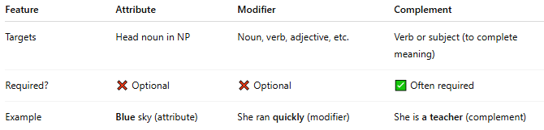
Feature | Attribute | Modifier | Complement
Targets | Head noun in NP | Noun, verb, adjective, etc. | Verb or subject (to complete meaning)
Required? | ❌ Optional | ❌ Optional | ✅ Often required
Example | Blue sky (attribute) | She ran quickly (modifier) | She is a teacher (complement)

✅ Common Position in Sentence:
# Source: AI Source: Provided by: [Data Path: Persons Table -> ID Column: 1, Name_En Column: Motasem Essam] -> From: [Chatgpt (GPT-4-turbo)] on [8/3/2025]
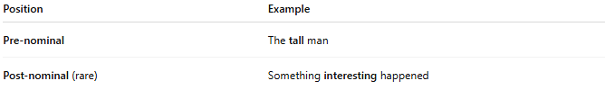
Position | Example
Pre-nominal | The tall man
Post-nominal (rare) | Something interesting happened

✅ Special Note:
# Source: AI Source: Provided by: [Data Path: Persons Table -> ID Column: 1, Name_En Column: Motasem Essam] -> From: [Chatgpt (GPT-4-turbo)] on [8/3/2025]
In some grammatical traditions (especially in systemic functional grammar or dependency grammar), the term "attribute" may also refer more broadly to any predicate adjective or complement in copular constructions (e.g., "She is happy"), though in most structural grammar systems, this would be called a subject complement, not an attribute.

✅ Summary:
# Source: AI Source: Provided by: [Data Path: Persons Table -> ID Column: 1, Name_En Column: Motasem Essam] -> From: [Chatgpt (GPT-4-turbo)] on [8/3/2025]
- An attribute is part of a noun phrase that describes or qualifies the head noun.
- It is usually an adjective or adjective phrase, but can take several forms (participle, genitive, noun, numeral).
- It serves a modifying function but specifically within noun phrases.

